Scripture
"Now as soon as it was day, there was no small stir among the soldiers, what was become of Peter."
Acts 12:18 (KJV)

Thought for Today
Whenever God’s people prayed in the Book of Acts, miraculous things happened; The Holy Spirit fell in then upper room, Peter was released from prison, thousands were saved, many mighty miracles were performed. Heaven shaking prayers causes Earth shaking events.

Peter was in prison. King Herod had arrested some people who belonged to the church. He’d had James, the brother of John, put to death with the sword. Seeing that it pleased the Jews, he arrested Peter, and put him in prison. So there sat Peter, guarded by sixteen soldiers each watch. His future was very precarious.

Some of the believers were fully aware of Herod’s intentions to kill Peter, “but prayer was made without ceasing of the church unto God for him” (12:5, KJV). They, no doubt, prayed with unusual urgency, unusual intensity, and unusual fervency. Indeed, they prayed with desperation.

The result was spectacular. “Suddenly an angel of the Lord appeared and a light shone in the cell. He struck Peter on the side and woke him up. ‘Quick, get up!’ He said, and the chains fell off Peter’s wrists” (v. 7, NIV). The angel of the Lord loosed Peter’s chains and freed him from prison. Then the Bible says, “Now as soon as it was day, there was no small stir among the soldiers, what was become of Peter.”

What brought the angel of the Lord from heaven to strike off Peter’s chains and free him? How were they able to pass through the first and second wards unnoticed? When they reached the iron gate that led to freedom, why did it open of its own accord?

Backing this great deliverance was great prayer. Many Christians were gathered together praying in a home well known for prayer. Mighty, believing, fervent prayer continued far into the night, until the astonishing answer came. Extraordinary praying brought an extraordinary answer. There was “no small stir”, both among the believers and the soldiers, when the news broke about Peter’s release.

On a previous occasion there was “no small stir”: when Peter visited Caesarea (Acts 10:5). Cornelius, the Roman centurion, had been instructed by the angel of God to send to Joppa for Simon Peter. Meanwhile, as Peter earnestly prayed, he fell into a trance, and God gave him a lesson in grace. As a result of Peter’s ministry in the house of Cornelius, there was “no small stir.” Peter had spoken but a few minutes when “the Holy Ghost fell on all them which heard the word” (10:44). On the Gentiles, as on the Jews, was poured out the gift of the Holy Spirit. Peter could not doubt it, for he heard them speak with tongues and magnify God. What caused this manifestation? Two men in separate places had prayed, earnestly and with faith. This was the startling answer: There was “no small stir.”

There was “no small stir” on the Day of Pentecost. As the disciples waited in prayer, there came a “sound from heaven as of a rushing mighty wind, and it filled all the house where they were sitting. And there appeared unto them cloven tongues like as of fire, and it sat upon each of them. And they were all filled with the Holy Ghost, and began to speak with other tongues, as the Spirit gave them utterance” (Acts 1:1-4, KJV).

News of the unusual event spread rapidly, and a curious crowd gathered. What they created was “no small stir.” In fact, Peter was obligated to stand up and explain: “These are not drunken, as ye suppose… But this is that which was spoken by the prophet Joel… I will pour out my Spirit upon all flesh” (2:15-17). That same day three thousand souls were saved. The origin of this “stir” were days of tarrying and prayer. The believer’s “all continued with one accord in prayer and supplication (1:14), until the Spirit fell upon them. There was “no small stir.”

There was “no small stir” at the Temple Gate in Acts 3:1-8, when the man - lame from birth - was healed and entered into the temple, walking and leaping and praising God. Onlookers were filled with “wonder and amazement” (3:10). There was “no small stir.”

There was “no small stir” when Philip went to Samaria and preached Christ (Acts 8:5). The people, with one accord, accepted his message. There was great joy in the city. People were converted, baptized, and healed. Then, the apostles in Jerusalem sent Peter and John who laid their hands on the believers, and they were filled with the Holy Spirit (8:17).

As we retrace the same pattern of prayer – praying in unity, praying in fervency, praying even in desperation – God will respond with amazing answers and there will be “no small stir.” Remember that earthshaking events are caused by heaven-moving prayer.

Prayer
“Thank you Lord for the privilege of prayer. Help me to pray more fervently. May a holy desperation grip my heart, as I see lost souls all around me. May there be “no small stir”, as a result of the power of the Holy Spirit working through my life. Amen.”

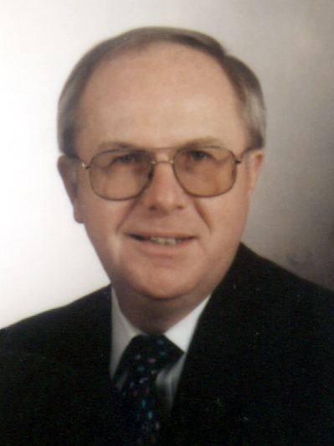 | Meet the Author  Paul D. Gibbon and his wife Joan pastored for 36 years with the Pentecostal Assemblies of NL. During this time, They ministered at Emmanuel Pentecostal Church, Deer Lake, Evangel Pentecostal Tabernacle, Grand Falls, and Glad Tidings Tabernacle, Embree . He spent many years in Youth Ministry. Paul and Joan are now semi- retired. They continue to minister on weekends and special occasions as well as pulpit supply. They may be reached by e-mail at paulandjoan37@hotmail.com

